FILL A PURSE

FOR A SISTER OR BROTHER CAMPAIGN

Most displaced men and women don’t have purses or bags and they definitely don’t have the items to put inside them. Most men and women like to carry a purse or wallet. There’s something about it that gives you a feeling of keeping your dignity intact. When you’re distraught—rushing out of the home away from violence, for instance—you may leave without your personal items. Our goal is to show other men and women that we care about them, that we are here for them.

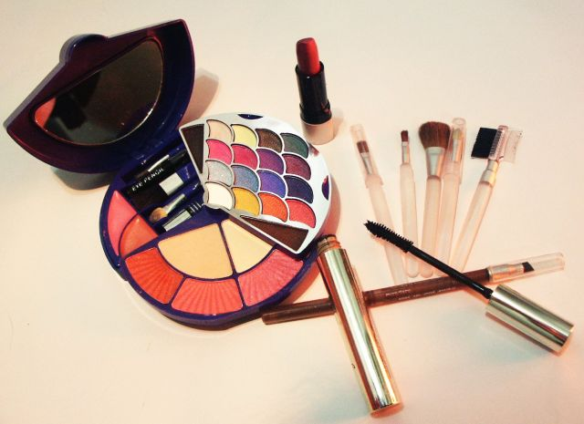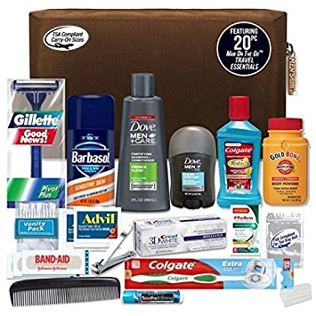

The Status of Women Committee will fill the purses and bags and distribute them.

