FILL A BAG FOR A SISTER OR BROTHER CAMPAIGN

Our goal is to show other women and men in need that we CARE about them, that we are HERE for them, that they do have people that will HELP them!!!

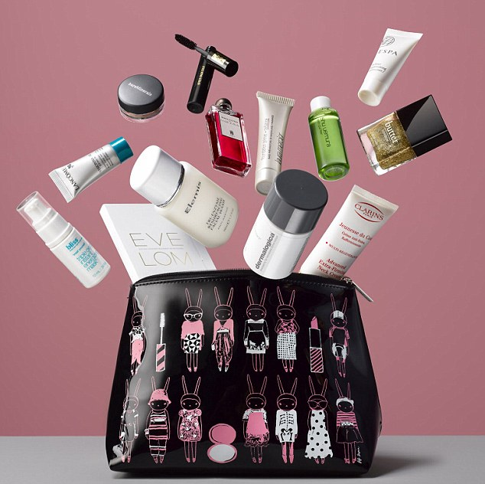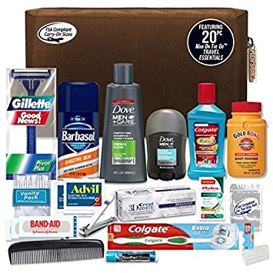

Please contribute by dropping off any of the following items (new, unopened):

Purses or Backpacks (new or slightly used), wallets, chain purses, Shampoo, Conditioner, Feminine Products, Tooth Brush, Tooth Paste, Deodorant, Chap Stick, Brush, Comb,

Small first aid kit, Gift Cards, Socks, Mittens

To
OSSTF DISTRICT 17 OFFICE
UNIT 6 - 51 KING ST.
From October 1st – November 27th

The Status of Women Committee will fill the bags and deliver them to the United Way on your behalf to be distributed.

